intermediate architectural design
Course Syllabus

Ms. Eimile Gavagan | egavagan@davincischools.org | www.gavagan.weebly.com

Course Description: Intermediate Architectural Design is a competency-based course intended to prepare students for architecture-related occupations. Through the lens of intentional design, students will learn about architectural history, sketching, eye manipulation, green design, 3D computer programs and many other facets of architecture. The student will learn these objectives as they find their own outlet as a designer and, perhaps most importantly, use the design process to continue to learn from their mistakes and redesign until they reach their full potential as budding architects. This class will challenge them to look at their own work critically and deal with failure as inspiration for success.

Course Hours: 2 semesters – 120 hours total

Course Goals: Students will –
- Increase awareness of the structures they encounter on a daily basis
- Put their ideas on paper to accurately represent what they imagine
- Learn to use critical feedback to become better designers
- Think about space in three dimensions
- Empathize more easily
- Recognize historical precedents in contemporary architecture
- Safely use a cutting blade to create excellently crafted objects
- Manipulate the viewer’s eye through intentional design choices
- Use contrast, color and height to differentiate space for a purpose
- Appreciate the complexities and necessity of sustainable design
- Have a near-complete digital portfolio showcasing their design capabilities
- Present their Proof of Learning during final presentations each semester

Mastery-Based Grading: Students will be subjected to Mastery-Based Grading in this course. This means that a student will be given multiple opportunities to demonstrate mastery throughout the semester. Objectives from all units will be consistently re-graded through DaVinci Design’s Art + Design Essential Skills listed below. This will constitute 70% of the grade. The other 30% will be accountability.

2017-2018 DaVinci Design Art + Design Essential Skills
- ESK1 – Foundational Art Skills
- ESK2 – Digital Tools
- ESK3 – Design Process
- ESK4 – Professional Skills

4 | A | Exceeds Expectations
3 | B | Meets Expectations
2 | C | Approaching Expectations
1 | I | Below Expectations
Grading the Essential Skills:
The details of what constitutes each level of grading will be outlined per project. Student will receive a rubric for each project the day the project is introduced.

Field Trips

Architecture students will take multiple field trips this year to see surrounding projects and to help your student find inspiration in excellent design. While these trips are extremely useful for the progress of a designer, students will only be allowed to go on field trips if they have had excellent classroom behavior. This includes minimal absences and tardies as well as adherence to classroom rules. Students will have a tracker that remains in the classroom that will help them know where they stand. Parents will have access to this information as well.

Classroom Expectations

Classroom Rules

- Do not impede another student’s learning.
- Give and receive critical feedback in a professional manner.
- Leave a place better than you found it.

Classroom Procedures

Procedures will be introduced and rehearsed by your student in the first week of school as well as any other time we are starting something new that may require new procedures. These procedures are in place to keep the learning environment running in an effective manner so that we can use the time we have together efficiently.

Absences/Tardies

Students will be counted as tardy if they walk into the classroom after the time class is designated to start. This means if class begins at 9:00am, the student is tardy if they arrive at 9:00am. 8:59am is the last possible time a student can arrive to class and not be counted as tardy.

Once a student accrues more than the designated number of absences/tardies before a field trip, the student will be ineligible to attend. The number of absences/tardies allowed will depend on how many days of class we have between field trips. You and your student will be told the number of allowed absences/tardies as soon as field trip dates are finalized.

If a student is absent, they will have two class periods to make up the missed work and submit it without penalty.

Late Work

Because of our Mastery-Based Grading system, students can turn in work up to a week late and still get full credit for the Art + Design Essential Skill being assessed. However, their accountability grade will go down as a result.

Accountability

Accountability is worth 30% of your student’s final grade. Factors that go into accountability include turning in work on time, doing their share of work when paired with another student, completing classwork or other assignments that are not directly connected to an Essential Skill, not bringing supplies to school when asked.

Materials Required

Item | Details/Description | Image (least expensive option shown) | Cost on Amazon
Sketchbook | Any size or brand will work, but I recommend those that are blank (no grid lines or writing lines), and approximately the size of a piece of paper (8.5x11). | 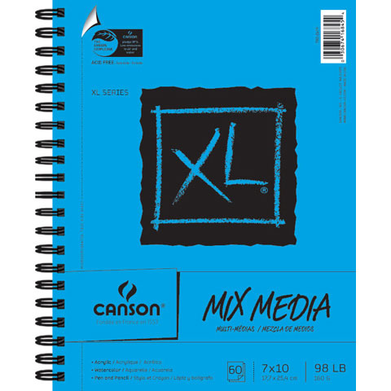
Triangular Architectural Scale | All brands/materials acceptable, but aluminum will be sturdier than plastic. NO ENGINEERS SCALE | 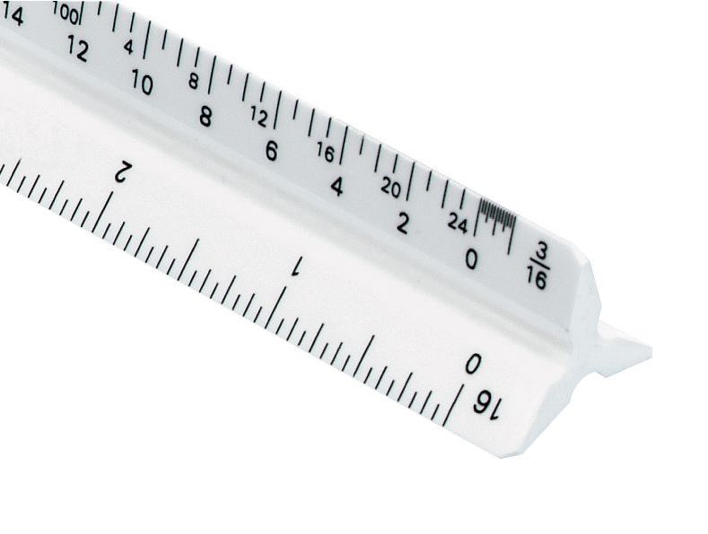 | $6.71+
Tacky Glue | Aleene’s Tacky glue, any size |  | $5.99+
X-Acto Knife | Extra blades provided in the classroom will be size #11, so X-Acto knives should use #11 blade, unless student wants to provide all their own blades. X-Acto #1 knife is the most basic. Any type of handle will work, the ones that have more cushion are more comfortable. | 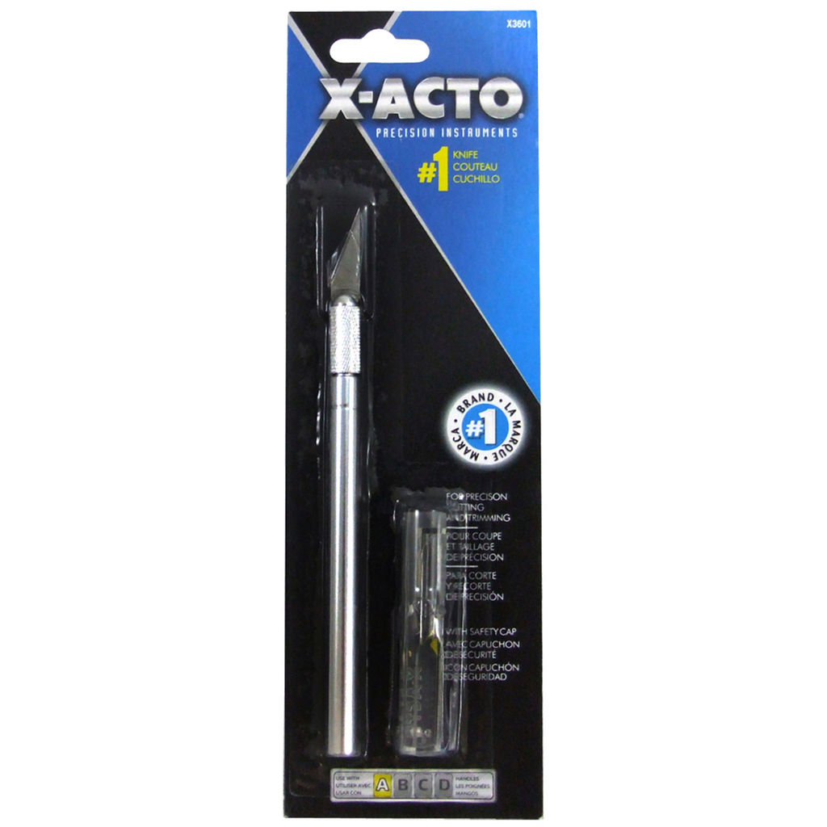 | $5.00+
X-Acto Knife Blades | #11 blade, OR the type of blade your student’s knife requires. Please purchase at leas the 40-pack. X-Acto knives are safest when they are sharp, so we plan on changing out the blades often. | 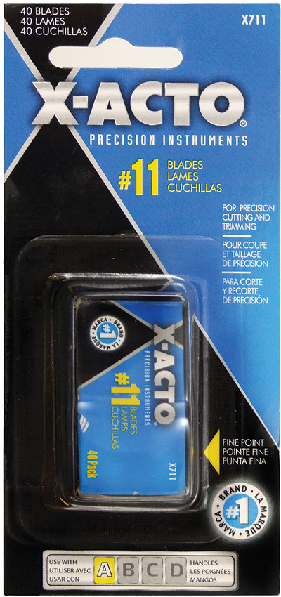 | $9.68+
Building Materials | TBD as your student moves through the class and decides what they’d like to build and how.

**All knives and blades will be stored in the classroom, unless the student has a need to bring home to work on a project outside of class. If there are any concerns about this, please contact me via e-mail.

Intermediate Architectural Design: Details + Assignments

This class will meet three times per week. We will meet on either Monday/Wednesday or Tuesday/Thursday for approximately 1.5 hours per day AND we will meet for approximately 40 minutes on Fridays.

Monday/Wednesday or Tuesday/Thursday classes:

During these times, students will work on their big projects, many of which take weeks or months to complete. These days will be filled with work time as much as possible, with time for critiques interspersed as needed. During this work time, I will be available for conferencing. Students will be able to sign up for conferencing as they see the need. Students who make a habit of conferencing with me tend to be more successful. The design process be definition requires multiple iterations of a project, so good feedback throughout the process is KEY. However, students work at different paces, so it has been most useful for students to be in charge of their own conferencing schedule.

Fridays:

Since Fridays are short, we will use them in a very different way compared to our classes during the week. We will use some of these Fridays to learn or practice sketching skills OR we will use this time to introduce the students to excellent designs of the recent or not-so-recent past so they can expand their knowledge of the history of architectural design. This is key for their development as designers themselves.

Semester 1 Projects:
Cube Project | Line Square Rectangle | LSR Repeating | Lines of Extension | Painted and 3d LOE

Semester 2 Projects:
Classroom Plans and Elevations | Sustainable Building Drawings | Passion Project Drawing Package
**Both semesters will have sketchbook checks and final submission at the end of the semester

DaVinci Design
12501 Isis Ave
Hawthorne, CA
310.725.5800

Please sign below, signifying you have read through this syllabus with your student.
Student, please return entire syllabus once it has been signed and dated.

___________________________________ parent/guardian signature _______________________ date

